 | Sanjivani Rural Educational Society’s SANJIVANI COLLEGE OF ENGINEERING  (An Autonomous Institution)  Kopargaon – 423 603, Maharashtra.
Academic Year: 2025-26 | CIA ACTIVITY REPORT | Revision: 00 Dated :
Department : | Information technology | Date of  Preparation : 19-04-2026
Course Code & Name: | PCIT208:Software Engineering Madeling And Design | Year/Sem:  SY Sem-II

Activity Title:
Smart Classroom Management System

Submitted by:

Roll  No. | PRN No. | Name of the Student | Signature
98 | 0124UITF1098 | Arti Bhausaheb Awari
99 | 0124UITM1099 | Kanifnath Rajendra Markad
100 | 0124UITF1100 | Reva Shantilal Pawar
101 | 0124UITM1101 | Abhishek Sachin Yeole

Course Incharge Dr. S.N.
Gunjal

INDEX

Sr.No. | Topic | Page no.
 | Abstract | 03
 | Project Definition | 04
 | Introduction | 05
 | Scope of the Project | 06
 | Objectives of the Project | 07
 | Literature Review / Background Study | 08
 | System Analysis  7.1 Existing System  7.2 Problems in Existing System  7.3 Proposed System | 09-10
 | Software Requirements Specification (SRS)  8.1 Functional Requirements  8.2 Non-Functional Requirements  8.3 Use Case Diagram  8.4 Use Case Description | 11-16
 | System Design  9.1 UML Diagrams  - Class Diagram  - Sequence Diagram  - Activity Diagram  - Sate chart Diagram  - Collaboration Diagram  - Component Diagram  - Deployment Diagram | 17-26
 | Data Flow Diagram (DFD) | 27-28
 | Control Flow Diagram(CFD) | 29-30
 | Conclusion | 31
 | References | 32

Abstract

Education plays a vital role in the development of students, but many classroom management activities such as attendance recording, assignment tracking, performance evaluation, communication, and resource sharing are still handled manually. In the existing classroom system, teachers rely on paper registers, manual grading, and offline communication, which often leads to data loss, time consumption, calculation errors, and lack of transparency.Although the traditional system is simple and familiar, it suffers from problems such as inefficiency, limited real-time updates, difficulty in tracking student performance, and poor communication between teachers, students, and parents.To overcome these challenges, a Smart Classroom Management System is proposed. The proposed system provides a centralized, web-based platform that helps teachers and administrators manage classroom activities digitally. It includes features such as student registration, digital attendance, assignment submission, grade management, timetable scheduling, notifications, and performance tracking.

Project Defination

The Smart Classroom Management System is a web-based application designed to automate and manage classroom activities efficiently. It helps in handling tasks such as student registration, attendance tracking, assignment management, result processing, and communication between teachers and students. The system replaces manual processes with a digital platform, ensuring accuracy, transparency, and real-time access to information.

Introduction

In the modern education system, effective classroom management is essential for improving learning outcomes. Traditional classroom management methods rely heavily on manual processes such as maintaining attendance registers, checking assignments, and calculating grades. These methods are time-consuming, error-prone, and lack proper communication.

The Smart Classroom Management System provides a digital solution to these problems by integrating various classroom activities into a single platform. It enables teachers to manage academic activities efficiently while allowing students to access information anytime. This system enhances productivity, reduces paperwork, and improves communication within the educational environment.

Scope Of Project

- The system supports student registration and attendance management.
- It can be used by teachers, students, and administrators.
- The system provides real-time updates and notifications.
- It stores academic records securely for future reference.
- It improves transparency, organization, and productivity in educational institutions.

Objectives of Project

- To develop an online platform for managing classroom activities.
- To maintain student records and attendance digitally.
- To simplify assignment submission and grade calculation.
- To improve communication between teachers, students, and parents.
- To reduce manual work and increase efficiency in classroom management.

Literature Review / Background Study

Classroom management has traditionally been carried out using manual methods such as maintaining attendance registers, handling paper-based assignments, and calculating results manually. These methods are simple but often lead to inefficiency, errors, and difficulty in maintaining records over time. Communication between teachers and students is also limited in such systems.

With the advancement of technology, various digital solutions like Learning Management Systems (LMS) and educational software have been introduced. These systems provide features such as online attendance, assignment submission, and performance tracking. They help in improving accessibility, reducing manual effort, and enabling better communication.

However, many existing systems are either too complex, expensive, or not fully integrated, making them less suitable for all educational institutions. Some systems focus only on specific functionalities and do not provide a complete solution for classroom management.

The Smart Classroom Management System is developed to overcome these limitations by providing a simple, user-friendly, and integrated platform. It combines all essential classroom activities such as attendance management, assignment handling, result processing, and communication into a single system, making it efficient and easy to use.

7.System Analysis

System Analysis is the process of studying the current system, identifying its limitations, and proposing a better solution. It helps in understanding the requirements of the system and designing an efficient and effective solution.

7.1 Existing System
The existing classroom management system is mainly manual and paper-based. Teachers maintain attendance using registers, assignments are submitted in physical form, and results are calculated manually. Communication between teachers and students is mostly done verbally or through notices.
The system does not use any centralized digital platform, making it difficult to store, manage, and retrieve data efficiently.

7.2 Problems in Existing System
The manual system has several limitations:
- Time-consuming and inefficient processes
- High chances of human errors in attendance and result calculation
- Difficulty in maintaining and storing records
- Lack of real-time updates
- Limited communication between teachers and students
- No proper tracking of student performance
- Risk of data loss or damage

7.3 Proposed System
The proposed Smart Classroom Management System provides a digital solution to overcome the limitations of the existing system. It is a web-based platform that automates classroom activities and improves efficiency.
The system includes features such as:
- Online student registration and login
- Digital attendance management
- Assignment submission and evaluation
- Result and grade management
- Notification and communication system
- Secure database for storing academic data
This system reduces manual work, improves accuracy, and provides real-time access to information, making classroom management more effective and organized.

8. Software Requirements Specification (SRS)

The Software Requirements Specification (SRS) defines the functional and non-functional requirements of the Smart Classroom Management System. It describes how the system should behave and the constraints under which it operates.

8.1 Functional Requirements
Functional requirements describe what the system should do.
- The system shall allow users (students, teachers, admin) to register and login
- The system shall manage student information and records
- The system shall record and maintain attendance digitally
- The system shall allow assignment upload and submission
- The system shall evaluate assignments and store marks
- The system shall generate and display results
- The system shall send notifications to users
- The system shall allow teachers to manage classroom activities
- The system shall store and retrieve data from the database

8.2 Non-Functional Requirements
Non-functional requirements define system performance and quality.
- Performance: System should respond quickly to user requests
- Security: Only authorized users can access the system
- Usability: System should be user-friendly and easy to operate
- Reliability: System should work without failure
- Scalability: System should handle multiple users
- Availability: System should be available when required
- Maintainability: System should be easy to update and maintain

8.3 Use Case Diagram

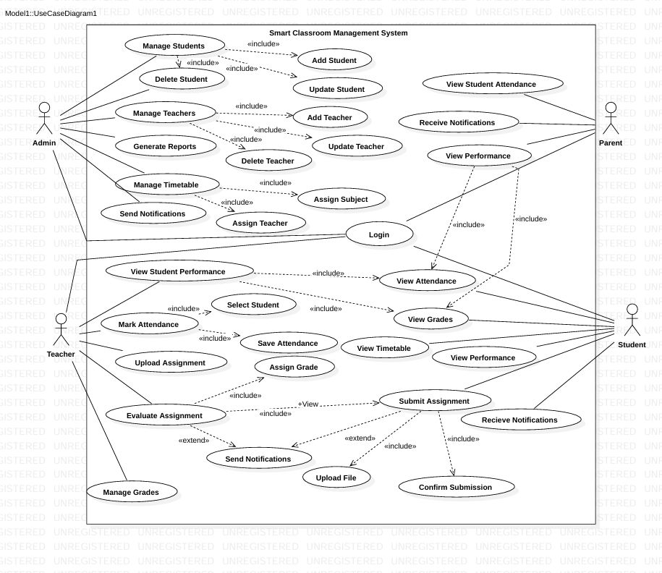
The Use Case Diagram represents the interaction between users and the system. It shows different functionalities such as login, attendance management, assignment handling, and result viewing performed by students and teachers.

8.4 Use Case Description

🔹 Use Case: Login
- Actor: Admin, Teacher, Student, Parent
- Description: User logs into the system using credentials
- Pre-condition: User must be registered
- Post-condition: User gets access to system
- Flow:
  - User enters username and password
  - System validates details
  - If valid → access granted
  - If invalid → error message displayed

🔹 Use Case: Manage Students
- Actor: Admin
- Description: Admin manages student records
- Includes: Add Student, Update Student, Delete Student
- Flow:
  - Admin selects manage student
  - Performs add/update/delete operation
  - System updates database

🔹 Use Case: Manage Teachers
- Actor: Admin
- Description: Admin manages teacher records
- Includes: Add Teacher, Update Teacher, Delete Teacher
- Flow:
  - Admin selects manage teacher
  - Performs required operation
  - System saves changes

🔹 Use Case: Manage Timetable
- Actor: Admin
- Description: Admin assigns subjects and teachers
- Includes: Assign Subject, Assign Teacher
- Flow:
  - Admin selects timetable
  - Assigns subjects and teachers
  - System updates timetable

🔹 Use Case: Mark Attendance
- Actor: Teacher
- Description: Teacher marks attendance
- Includes: Select Student, Save Attendance
- Flow:
  - Teacher selects class
  - Marks attendance
  - Saves attendance

🔹 Use Case: Upload Assignment
- Actor: Teacher
- Description: Teacher uploads assignments
- Flow:
  - Teacher selects assignment option
  - Uploads assignment
  - System stores it

🔹 Use Case: Evaluate Assignment
- Actor: Teacher
- Description: Teacher evaluates assignments
- Includes: Assign Grade
- Extends: Send Notification
- Flow:
  - Teacher checks submission
  - Assigns marks
  - System updates result

🔹 Use Case: Submit Assignment
- Actor: Student
- Description: Student submits assignment
- Includes: Upload File, Confirm Submission
- Flow:
  - Student selects assignment
  - Uploads file
  - Confirms submission

🔹 Use Case: View Attendance
- Actor: Student, Parent
- Description: View attendance records
- Flow:
  - User selects attendance
  - System displays attendance

🔹 Use Case: View Grades
- Actor: Student
- Description: Student views grades
- Flow:
  - Student selects grades
  - System displays marks

🔹 Use Case: View Performance
- Actor: Student, Parent
- Description: View overall performance
- Flow:
  - User selects performance
  - System shows analysis

🔹 Use Case: Receive Notifications
- Actor: Student, Parent
- Description: Receive updates and alerts
- Flow:
  - System sends notification
  - User receives it

9.System Design
System Design describes the overall structure and working of the Smart Classroom Management System using different UML diagrams. These diagrams help in understanding the system behavior, structure, and interaction between components.

9.1 UML Diagrams
🔹 Class Diagram
The Class Diagram represents the static structure of the system. It shows different classes such as Student, Teacher, Admin, Assignment, Attendance, and Result along with their attributes and relationships. It helps in understanding how data is organized in the system.
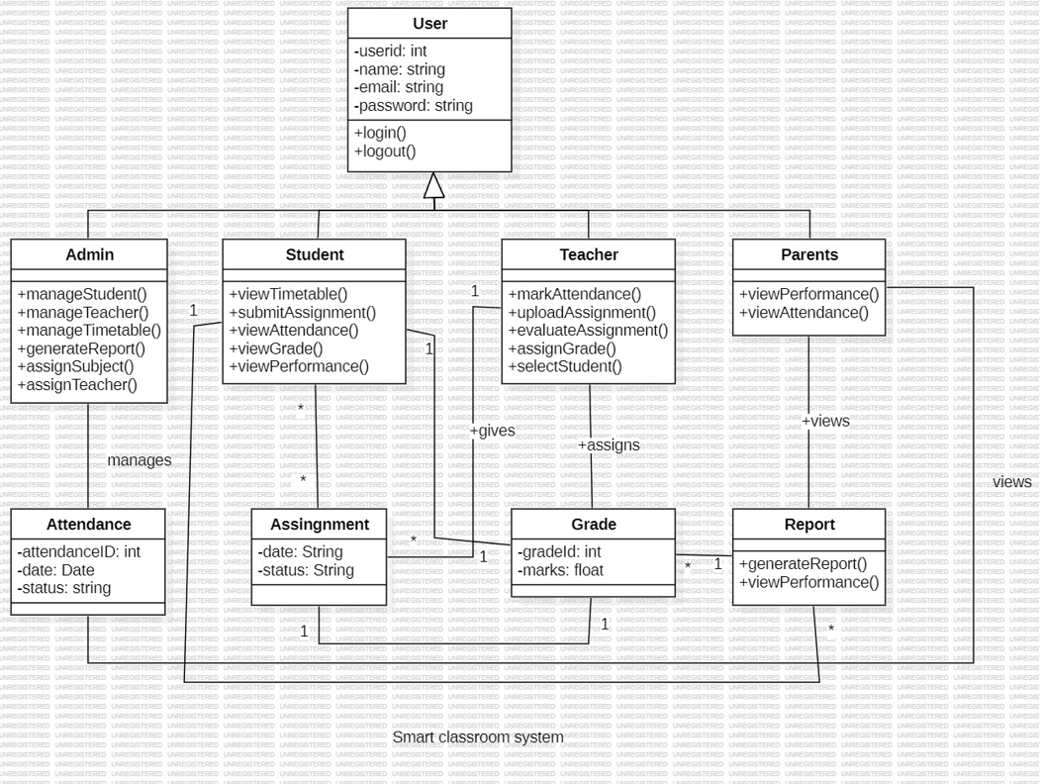
🔹 Sequence Diagram
The Sequence Diagram shows the interaction between different objects in a sequence of time. It represents how messages are exchanged between user and system during operations like login, attendance marking, assignment submission, and result viewing.
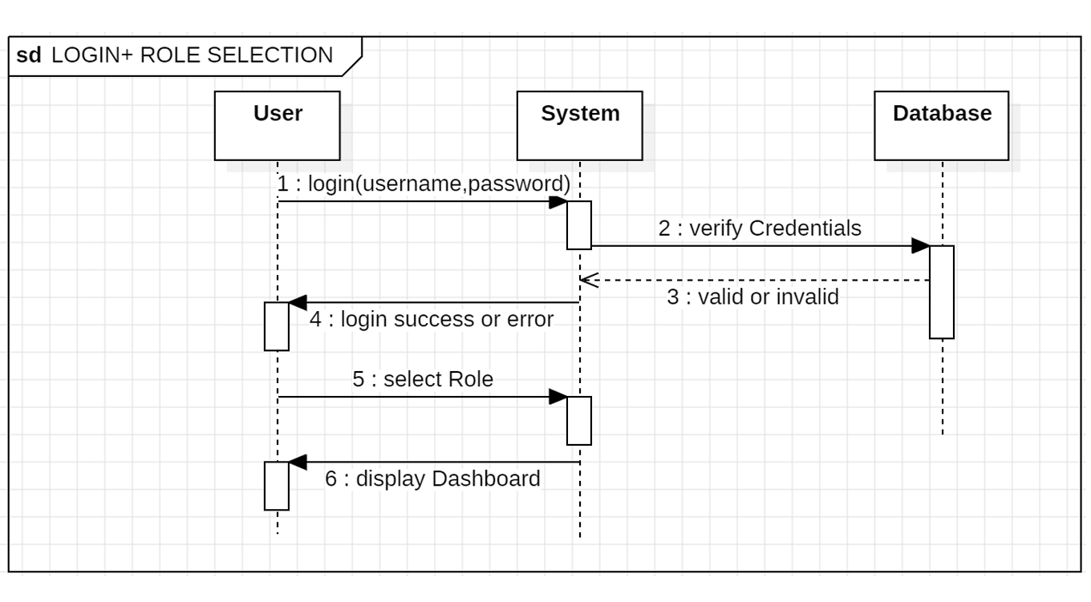
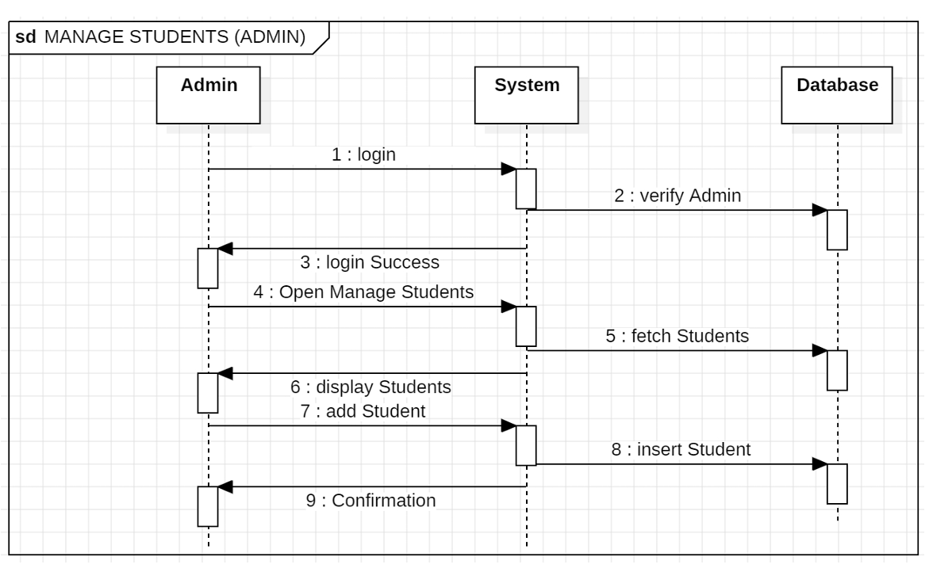
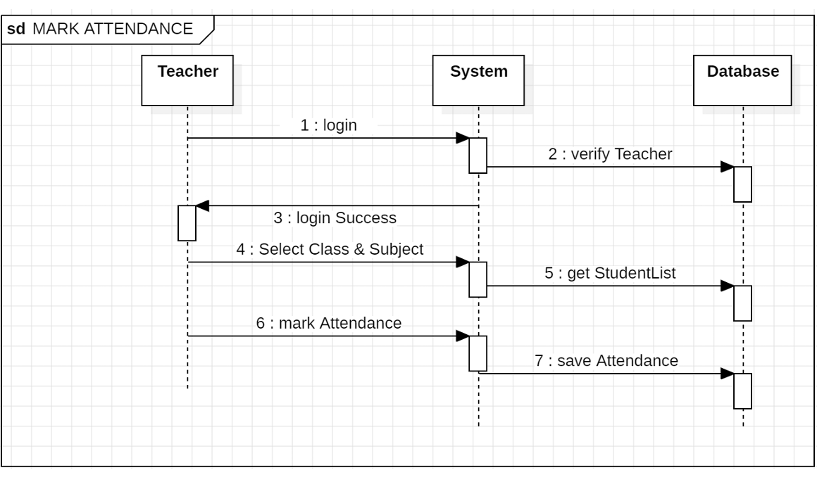
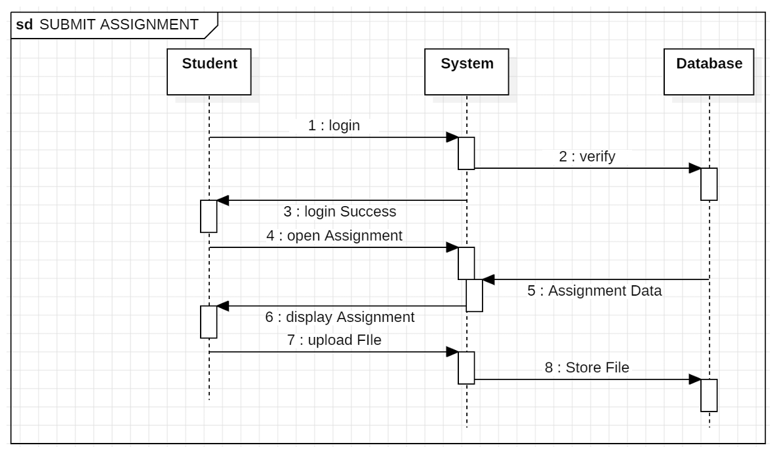
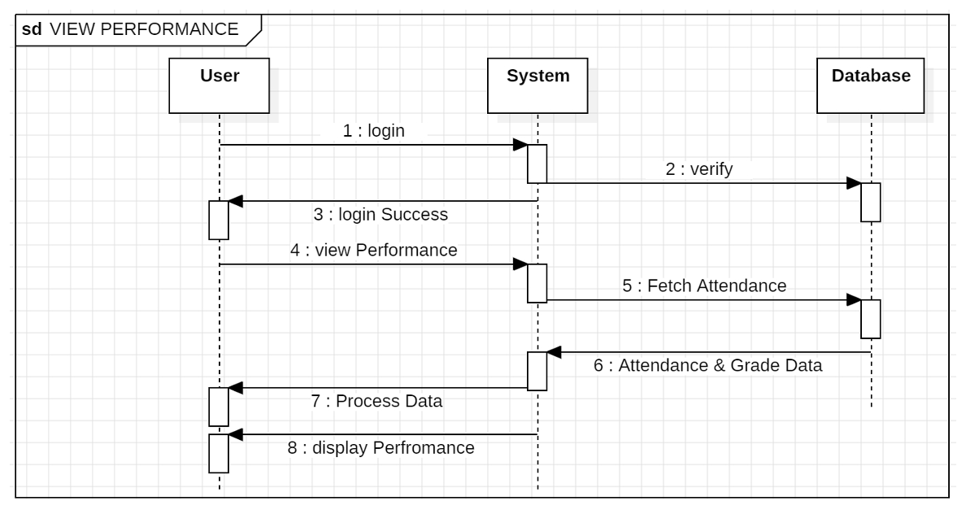

🔹 Activity Diagram
The Activity Diagram represents the flow of activities in the system. It shows step-by-step processes such as login, validation, selecting activity, performing action, and generating response.

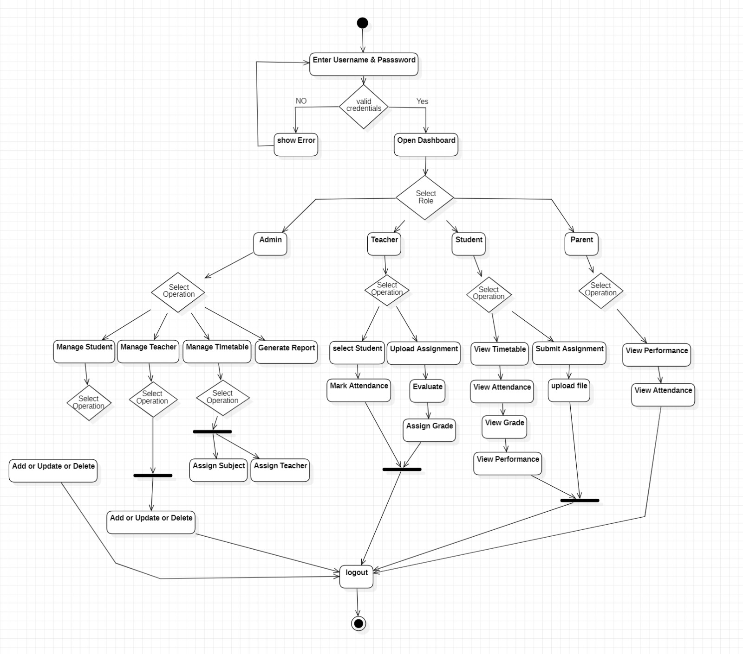

🔹 State Chart Diagram

The State Chart Diagram shows different states of the system and transitions between them. For example, login state, validation state, dashboard state, and action states like attendance, assignment, and result.

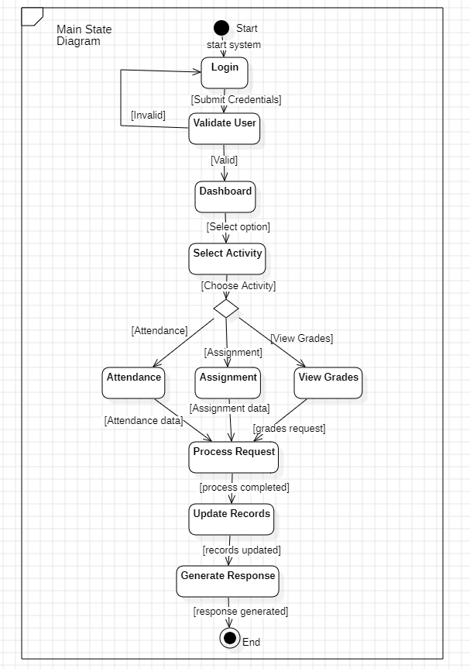
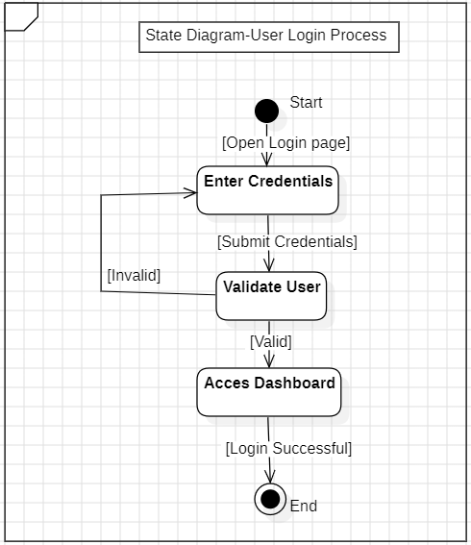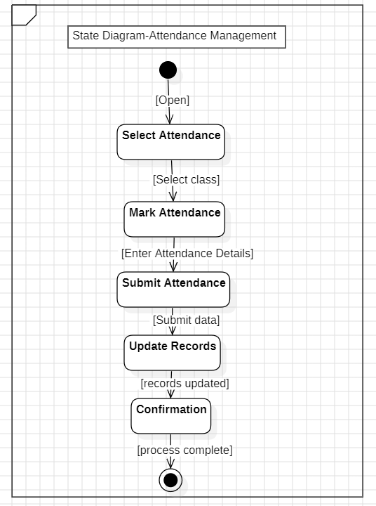
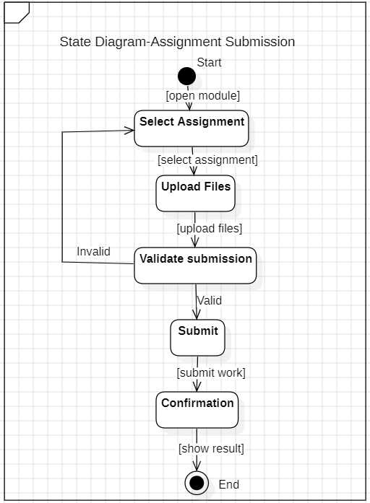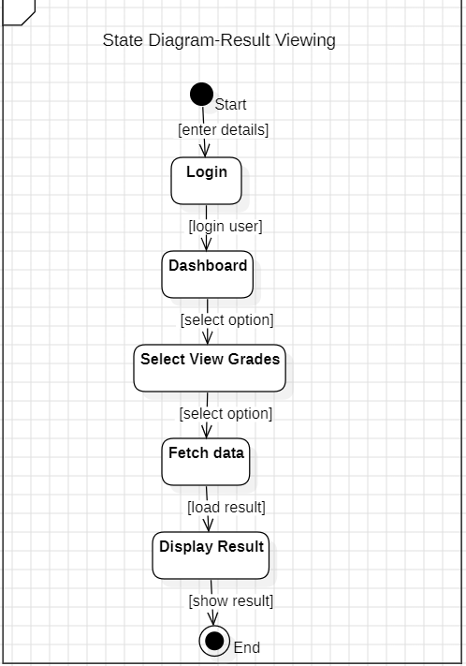
🔹 Collaboration Diagram
The Collaboration Diagram shows how different objects interact and collaborate with each other to perform a task. It focuses on relationships and communication between system components.

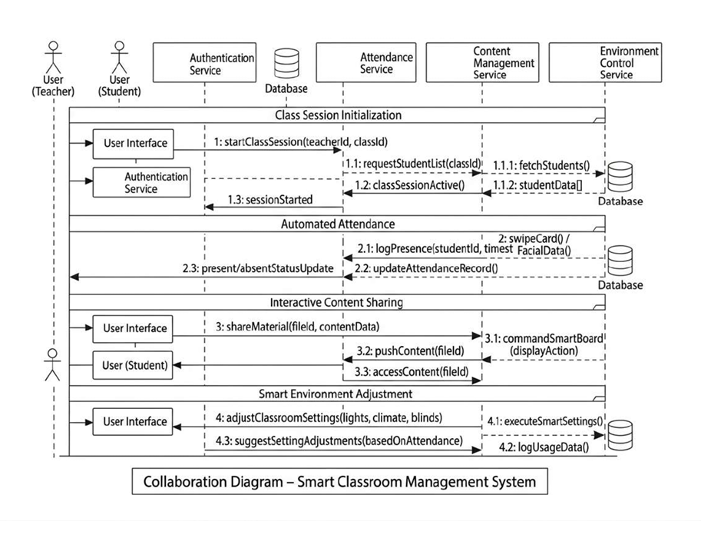

🔹 Component Diagram
The Component Diagram represents different modules of the system such as User Interface, Authentication Module, Attendance Module, Assignment Module, and Database. It shows how these components are connected.
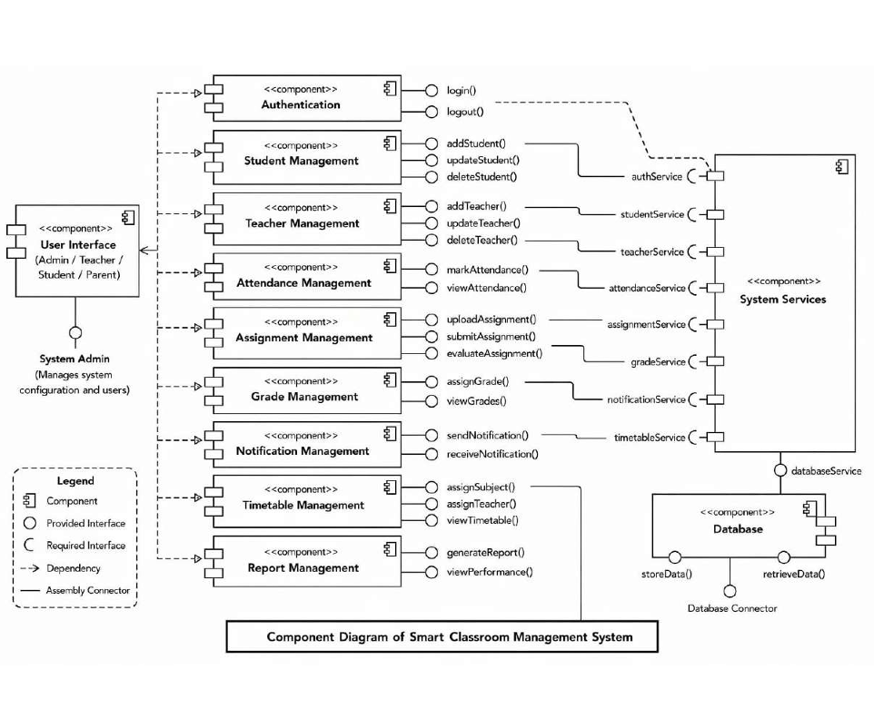

🔹 Deployment Diagram
The Deployment Diagram shows the physical structure of the system. It represents hardware components such as client devices, server, and database, and how they are connected through a network.

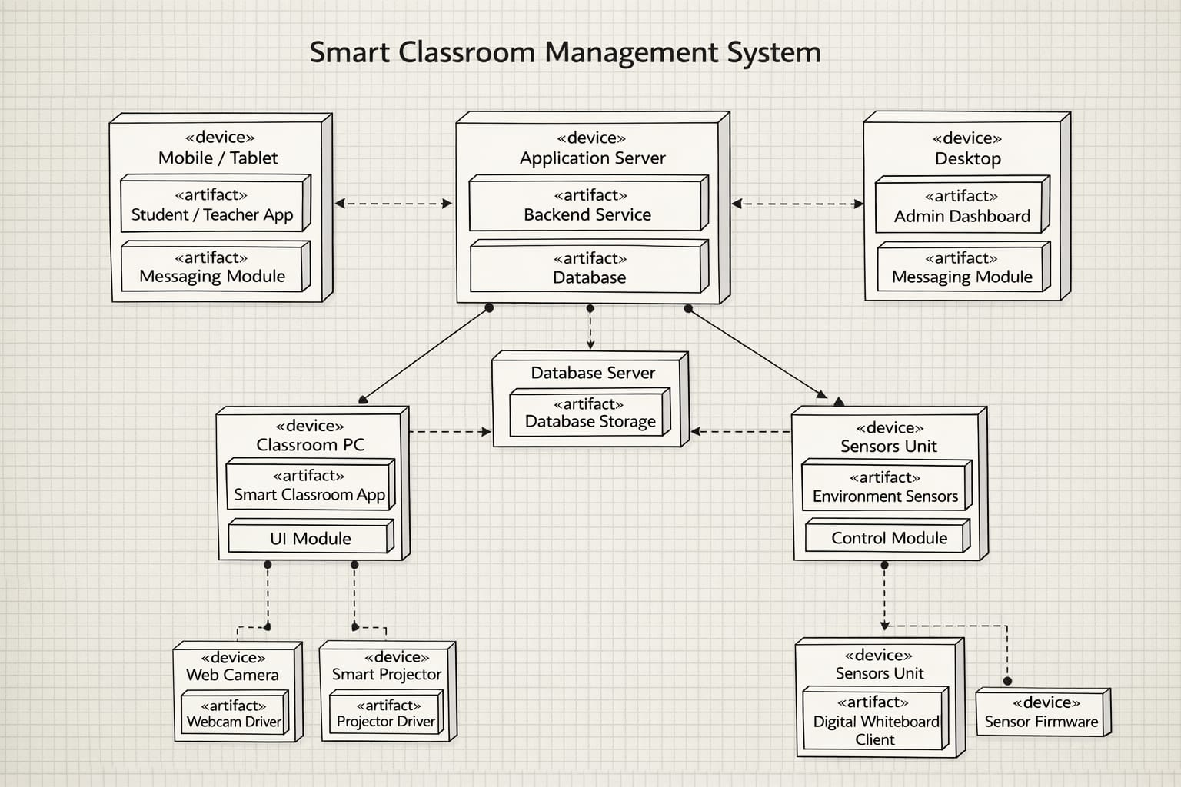

10. Data Flow Diagram (DFD)

The Data Flow Diagram represents the flow of data within the system. It shows how data moves between external entities, processes, and data stores.
- Level 0 (Context Diagram): Shows overall system as a single process interacting with Student and Teacher
- Level 1 DFD: Breaks the system into multiple processes like authentication, attendance, assignment, and result management
DFD helps in understanding how input is processed and transformed into output within the system.
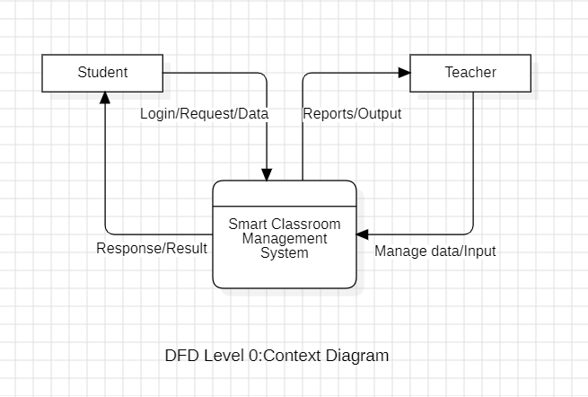
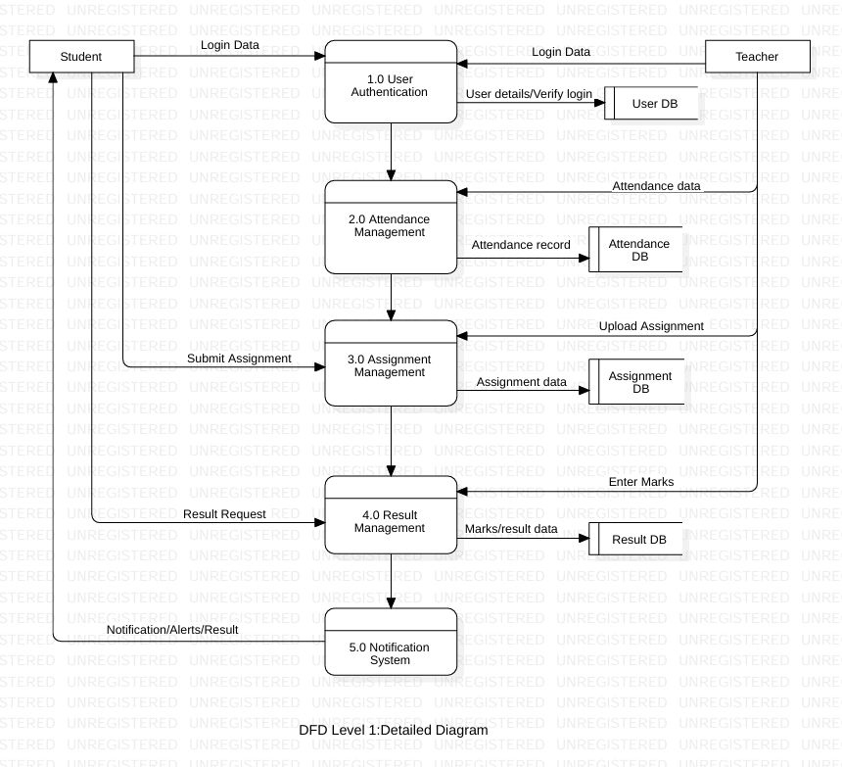

11. Control Flow Diagram (CFD)

The Control Flow Diagram represents the flow of control in the system. It shows the sequence of operations and decision-making steps.
In the Smart Classroom Management System, the control flow starts from login, followed by user validation. Based on validation, the system either allows access or redirects back to login. After successful login, the user selects an activity such as attendance, assignment, or viewing results. The system then performs the selected action, updates records, and generates a response.
The diagram helps in understanding the logical flow and control structure of the system.
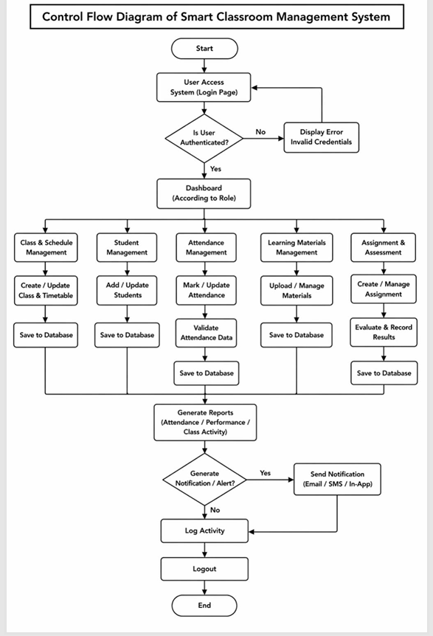

12. Conclusion
The Smart Classroom Management System is an effective solution for modernizing traditional classroom activities. It successfully replaces manual processes such as attendance recording, assignment handling, and result calculation with a digital and automated system. This reduces human effort, minimizes errors, and saves time for both teachers and students.
The system provides a centralized platform where all academic activities can be managed efficiently. Features like digital attendance, assignment submission, grade management, and real-time notifications improve communication and transparency within the educational environment. It also ensures secure storage and easy retrieval of student data, which is difficult in manual systems.
By using this system, teachers can focus more on teaching rather than administrative tasks, while students can access their academic information anytime and anywhere. The system also helps in better monitoring of student performance and progress.
In conclusion, the Smart Classroom Management System enhances efficiency, accuracy, and organization in classroom management. It is a reliable and scalable solution that can be implemented in schools and colleges to improve overall academic management and productivity.

13.References

- Software Engineering
- Software Engineering: A Practitioner's Approach
- StarUML – Used for creating UML diagrams
- Study material and notes provided by subject teacher
- Online tutorials and resources related to UML diagrams and system design
- Various educational websites for understanding DFD, UML, and software development concepts

